MINISTRY OF EDUCATION AND TRAINING MINISTRY OF FINANCE
ACADEMY OF FINANCE
---------

PhD Candidate DAO THU HA

THE IMPACT OF OWNERSHIP STRUCTURE ON THE PROFITABILITY OF LISTED LOGISTICS ENTERPRISES IN VIETNAM

Major: Finance and Banking
Code: 9.34.02.01

SUMMARY OF DOCTORAL DISSERTATION IN ECONOMICS

HANOI - 2026

The dissertation was completed at:
ACADEMY OF FINANCE

Scientific supervisors:
1. Assoc. Prof., PhD. Đoàn Hương Quỳnh
2. Assoc. Prof., PhD. Nguyễn Thế Anh

Reviewer 1: ........................................................................
........................................................................

Reviewer 2: ........................................................................
........................................................................

Reviewer 3: ........................................................................
........................................................................

The dissertation will be defended before the Academy-level Dissertation Assessment Council at the Academy of Finance.
At .... hour ...., on .... .... 2026.

INTRODUCTION

1. Rationale of the research topic
In the context of international economic integration, global supply-chain reconfiguration and the rapid expansion of e-commerce, logistics has increasingly become a key service infrastructure for national competitiveness. For listed logistics enterprises in Vietnam, profitability reflects not only the efficiency of asset use, equity utilization and operating capability, but also the quality of corporate governance and the configuration of ownership structure.
Logistics is a capital-intensive industry that depends heavily on infrastructure, technology, customer networks and international connectivity. Accordingly, the participation of different shareholder groups may generate different effects on financial performance. In practice, listed logistics enterprises are simultaneously affected by state divestment, the increasing presence of foreign investors, rising ownership concentration and stricter requirements for transparency in the securities market.
Based on these theoretical and practical requirements, the dissertation selects the topic "The impact of ownership structure on the profitability of listed logistics enterprises in Vietnam". The study contributes empirical evidence on the relationship between ownership structure and profitability in a distinctive infrastructure-related service industry, and provides a basis for proposing solutions to improve ownership structure, profitability, governance quality and competitiveness of listed logistics enterprises in Vietnam.
2. Literature review
Domestic and international studies have clarified the role of ownership structure in operating performance, firm value and profitability. However, most Vietnamese studies have used multi-industry samples, have paid limited attention to listed logistics enterprises, have not simultaneously examined state ownership (SO), foreign ownership (FO), insider ownership (IO) and concentrated ownership (CO) in the post-COVID-19 period, and have not fully analyzed differences across logistics segments. These limitations constitute the research gap addressed by the dissertation.
3. Research objectives and tasks
3.1. Research objective
The objective of the dissertation is to propose solutions for improving ownership structure in order to enhance the profitability of listed logistics enterprises in Vietnam.
3.2. Research tasks
To achieve this objective, the dissertation performs the following tasks: systematizing the theoretical foundations of ownership structure, profitability and the mechanisms through which ownership structure affects profitability; analyzing the current ownership structure and profitability of listed logistics enterprises; developing and testing quantitative models; and, on that basis, proposing appropriate solutions.
4. Research questions
The research questions focus on the theoretical foundations and measurement of ownership structure; the current status of ownership structure and profitability by stock exchange, firm size and logistics segment; the relationships between SO, FO, IO and CO and the two profitability indicators ROA and ROE; differences across logistics segments; and the orientation for improving ownership structure in the coming period.
5. Research object and scope
The research object is the impact of ownership structure on firm profitability. The spatial scope comprises 58 logistics enterprises listed on the Ho Chi Minh City Stock Exchange and the Hanoi Stock Exchange. The time scope covers the period 2019-2024. In terms of content, ownership structure is examined through state ownership, foreign ownership, insider ownership and concentrated ownership, while profitability is measured mainly by ROA and ROE.

6. Research methodology
The dissertation combines qualitative and quantitative methods. Qualitative methods are used to review theories, synthesize domestic and foreign studies, analyze the logistics context, identify research gaps and interpret empirical findings. Descriptive statistics are used to portray sample characteristics, ownership structure, financial structure and profitability of listed logistics enterprises.
Quantitative analysis is conducted on panel data for 58 enterprises over 2019-2024. The dissertation employs Pooled OLS, FEM, REM and FGLS models, together with model selection tests, multicollinearity tests, heteroskedasticity tests and autocorrelation tests. FGLS is used to address model defects when the data exhibit heteroskedasticity and autocorrelation.
7. Contributions of the dissertation
The dissertation makes four main contributions. First, it supplements the theoretical foundation on the impact of ownership structure on profitability in the logistics industry. Second, it provides updated empirical evidence for the post-COVID-19 period. Third, it simultaneously tests SO, FO, IO and CO in a single model. Fourth, it proposes a system of solutions for improving ownership structure in association with segment characteristics, empirical results and governance requirements for listed enterprises.
8. Structure of the dissertation
In addition to the Introduction, Conclusion and Appendices, the dissertation consists of three chapters:
Chapter 1: Theoretical foundations of the impact of ownership structure on firm profitability.
Chapter 2: Current status of the impact of ownership structure on the profitability of listed logistics enterprises in Vietnam.
Chapter 3: Solutions to improve ownership structure in order to enhance the profitability of listed logistics enterprises in Vietnam.

CHAPTER 1: THEORETICAL FOUNDATIONS OF THE IMPACT OF OWNERSHIP STRUCTURE ON FIRM PROFITABILITY
1.1. Ownership structure of enterprises
1.1.1. Concept and classification of ownership structure
Within the scope of the dissertation, the ownership structure of a joint-stock enterprise is understood as the distribution of share ownership, voting rights, control rights and financial benefits among shareholder groups. Ownership structure does not merely indicate who owns how many shares; it also reflects the concentration of power, the ability to influence governance decisions and the mechanism for allocating benefits among controlling shareholders, minority shareholders and managers.
The dissertation classifies ownership structure according to multiple criteria. Based on the degree of control concentration, ownership structure can be divided into dispersed ownership and concentrated ownership. Based on shareholder identity, the dissertation distinguishes state ownership (SO) from non-state ownership, with the latter including domestic private shareholders, foreign shareholders, institutional shareholders and individual shareholders. Based on the position of owners relative to the enterprise, the dissertation distinguishes insider ownership (IO) from external ownership.
In terms of control, the dissertation uses concentrated ownership (CO) to reflect the control power of large shareholders. CO is not an independent ownership group by identity; rather, it is a measure of the concentration of ownership or voting rights. Therefore, the largest shareholder may simultaneously be the State, a foreign investor, an insider or a domestic institution. This approach avoids the mechanical assumption that SO, FO, IO and CO are mutually exclusive.
1.1.2. Indicators for assessing ownership structure
Ownership structure is assessed through the ownership ratios of different shareholder groups and the degree of concentration of control rights. In the dissertation, SO, FO and IO reflect the identity or position of owners, whereas CO reflects the concentration of control by large shareholders and may overlap with SO, FO or IO depending on each enterprise.
1.1.3. Factors affecting ownership structure
Ownership structure is influenced by firm size, capital requirements, asset characteristics, the history of equitization, foreign ownership limits, disclosure requirements, the degree of minority shareholder protection and the enterprise’s profitability prospects. For listed logistics enterprises, the need for long-term capital and the characteristics of infrastructure assets are particularly important determinants.
1.1.4. Role of ownership structure
Ownership structure shapes the monitoring mechanism, the allocation of control rights, strategic orientation, resource access, risk control and the protection of shareholder interests. In logistics enterprises, this role is especially pronounced because the industry is capital-intensive and depends heavily on infrastructure, technology and market networks.
1.2. Profitability of enterprises
1.2.1. Concept and role of profitability
Profitability is the ability of an enterprise to generate profit commensurate with the scale of resources it mobilizes and uses. Unlike profit, which is an absolute amount reflecting the difference between revenue and expenses during a period, profitability is a relative measure that captures the economic efficiency of assets, equity and invested resources.
For listed enterprises, profitability provides an important signal for investors, creditors, managers and regulators. It indicates whether the enterprise can create adequate returns, maintain operations, finance reinvestment, withstand shocks and improve firm value over time.
1.2.2. Indicators for assessing profitability
The dissertation focuses on ROA and ROE. ROA reflects the efficiency of using total assets and is particularly meaningful for the logistics industry because enterprises must invest substantially in seaports, ICDs, warehouses, fleets, transport vehicles and operating technologies. ROE reflects the return generated for shareholders and is affected by financial leverage and capital structure. The simultaneous analysis of ROA and ROE therefore enables the dissertation to evaluate both asset-use efficiency and shareholder return.
1.2.3. Factors affecting profitability
Profitability is affected by internal factors such as firm size, financial leverage, growth, asset-use efficiency and cost management. It is also influenced by industry characteristics, the macroeconomic environment, logistics infrastructure and corporate governance quality. In logistics, the high level of fixed assets and the volatility of freight rates, fuel costs and trade flows make profitability particularly sensitive to both internal management and external conditions.
1.3. The impact of ownership structure on firm profitability
1.3.1. Fundamental theories explaining the impact of ownership structure on profitability
The dissertation applies agency theory, property rights theory and resource dependence theory to explain how different ownership groups may affect profitability. These theories suggest that ownership structure can reduce agency costs and strengthen monitoring, but it may also create conflicts of interest when control rights become excessively concentrated.
Agency theory emphasizes the relationship between owners and managers and between controlling and minority shareholders. Property rights theory highlights the importance of clearly defined ownership and control rights in motivating efficient resource use. Resource dependence theory explains how strategic shareholders may provide capital, technology, management experience, market access and monitoring capability.
1.3.2. Mechanisms through which ownership structure affects profitability
Ownership structure affects profitability through four major mechanisms. The first is the monitoring mechanism that reduces agency costs. The second is the resource access mechanism that improves managerial and operational capabilities. The third is the mechanism through which owners influence capital structure, investment policy and financial decisions. The fourth is the mechanism of information transparency and corporate governance quality. These mechanisms explain why the same ownership type may produce different effects depending on enterprise characteristics and logistics segments.
1.4. Research model on the impact of ownership structure on firm profitability
1.4.1. Research hypotheses
Based on agency theory, property rights theory and resource dependence theory, the dissertation develops hypotheses regarding the effects of state ownership, foreign ownership, insider ownership and concentrated ownership on profitability. Since theory and empirical evidence suggest that each ownership type may have either positive or negative effects depending on the context, the dissertation adopts an open and cautious approach in interpreting the empirical results.
1.4.2. Research model
The research model is developed with two dependent variables, ROA and ROE. The main independent variables are SO, FO, IO and CO. The control variables are SIZE, LEV and GROWTH, which are included to control for the effects of firm size, financial leverage and revenue growth.
The general model is specified as follows:
ROA_{it} = β₀ + β₁SO_{it} + β₂FO_{it} + β₃IO_{it} + β₄CO_{it} + β₅SIZE_{it} + β₆LEV_{it} + β₇GROWTH_{it} + ε_{it}
ROE_{it} = β₀ + β₁SO_{it} + β₂FO_{it} + β₃IO_{it} + β₄CO_{it} + β₅SIZE_{it} + β₆LEV_{it} + β₇GROWTH_{it} + ε_{it}
In these models, i denotes the enterprise and t denotes the year of observation. SO, FO and IO reflect owner identity or owner position, whereas CO reflects the concentration of control. This approach is consistent with the reality of listed enterprises, in which a shareholder may simultaneously belong to several ownership dimensions.
1.5. International experience in improving ownership structure to enhance profitability and lessons for Vietnamese logistics enterprises
1.5.1. Experience of international logistics enterprises
International experience indicates that there is no universally optimal ownership structure for all enterprises. For logistics and infrastructure-service enterprises, an appropriate ownership structure must be associated with capital intensity, technological dependence, international connectivity and risk-control requirements. Foreign ownership may support enterprises in accessing technology, customer networks and governance standards; however, its effectiveness depends on the strategic nature of investors and the absorptive capacity of firms.
State ownership may bring advantages in terms of resource access, infrastructure and stability in strategic segments; however, if the representation and monitoring of state capital are not transparent, enterprises may have weaker incentives to improve efficiency. Concentrated ownership can strengthen monitoring but may also increase the risk of control abuse when mechanisms for protecting minority shareholders are insufficient. Insider ownership can align managerial and shareholder interests, but without performance-based conditions, its positive effect may not be clear.
1.5.2. Lessons for Vietnamese logistics enterprises
The lessons for Vietnamese logistics enterprises are that ownership structure should be improved selectively and linked to the goal of sustainable ROA and ROE enhancement; strategic shareholders should be attracted instead of merely increasing ownership ratios; state capital should be restructured according to a clear roadmap; minority shareholders should be protected; and insider ownership should be conditional, linked to governance responsibility and operating performance.
Conclusion of Chapter 1
Chapter 1 systematizes the theoretical foundations of ownership structure, profitability, impact mechanisms and the research model. This serves as the basis for analyzing the current situation and empirically testing the impact of ownership structure on the profitability of listed logistics enterprises in Vietnam.
CHAPTER 2: CURRENT STATUS OF THE IMPACT OF OWNERSHIP STRUCTURE ON THE PROFITABILITY OF LISTED LOGISTICS ENTERPRISES IN VIETNAM
2.1. Overview of listed logistics enterprises in Vietnam
2.1.1. Formation and development of the logistics industry in Vietnam
Vietnam’s logistics industry has developed together with economic integration, the expansion of international trade, the improvement of transport infrastructure and the growth of e-commerce. Logistics has increasingly become an important infrastructure service that supports production, distribution and import-export activities.
2.1.2. Introduction to listed logistics enterprises in Vietnam
The research sample consists of 58 listed logistics enterprises in Vietnam. Among them, 36 enterprises are listed on the Ho Chi Minh City Stock Exchange, accounting for 62.1%, and 22 enterprises are listed on the Hanoi Stock Exchange, accounting for 37.9%. The enterprises are classified into five segments: seaport and ICD operations; maritime transport and ship agency; warehousing and forwarding; express delivery and next-generation 3PL; and air logistics.
By business segment, warehousing and forwarding is the largest group with 17 enterprises, accounting for 29.3%. The seaport and ICD group includes 15 enterprises, accounting for 25.9%. Maritime transport and ship agency includes 12 enterprises, accounting for 20.7%. Express delivery and 3PL includes 10 enterprises, accounting for 17.2%. Air logistics includes 4 enterprises, accounting for 6.9%.
2.1.3. Business characteristics of listed logistics enterprises in Vietnam
By firm size, the sample includes 14 large enterprises, 26 medium-sized enterprises and 18 small enterprises. This structure indicates that listed logistics enterprises are highly diverse in scale, business model and asset intensity. Therefore, the analysis of ownership effects should be placed in the context of differences across segments rather than relying only on the average values of the whole industry.
2.1.4. Overview of business performance and financial position of listed logistics enterprises in Vietnam
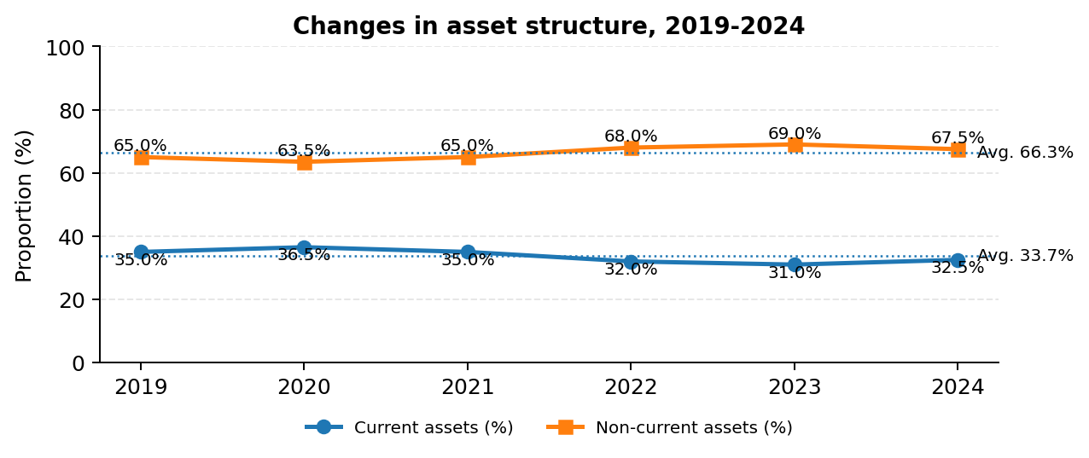
The asset structure of listed logistics enterprises during 2019-2024 shows that non-current assets consistently account for the dominant share. On average, non-current assets represent about 66.3% of total assets, whereas current assets account for about 33.7%. This reflects the capital-intensive nature of logistics, which depends heavily on seaports, ICDs, warehouses, vehicles, distribution centers and technological systems.
The capital structure indicates that liabilities account for about 58.0% on average, while equity accounts for 42.0%. Short-term debt represents about 32.8% and long-term debt about 25.2%. The relatively high use of debt both facilitates investment expansion and increases financial-cost pressure and liquidity risk. Therefore, ROE must be interpreted cautiously because it may be amplified by leverage rather than purely reflecting core operating efficiency.
Average business performance shows that net revenue decreased from VND 7,200 billion in 2019 to VND 6,200 billion in 2024, with a CAGR of -2.9%. Profit after tax decreased from VND 750 billion to VND 650 billion, with a CAGR of -2.8%. ROA declined from 6.1% to 5.2%, while ROE declined from 12.5% to 10.4%. Although the indicators recovered after 2020, they had not returned to their 2019 levels by the end of the research period, indicating unstable profitability.
2.2. Current status of ownership structure and profitability of listed logistics enterprises in Vietnam
2.2.1. Current ownership structure of listed logistics enterprises in Vietnam
The ownership structure of listed logistics enterprises reflects the simultaneous presence of state capital, foreign capital, insider ownership and a high degree of concentration among large shareholders. Over the research period, the average state ownership ratio is about 29.43%, foreign ownership 10.68%, insider ownership 8.23% and concentrated ownership 60.28%.
The time trend shows a slight decline in state ownership, from 31.20% in 2019 to 29.44% in 2024. Foreign ownership increased from 9.50% to 10.68%, reflecting growing foreign investor interest, although the level of participation remains modest. Insider ownership increased slightly from 7.80% to 8.24%, while concentrated ownership decreased only marginally from 61.00% to 60.28%.
Across segments, seaport and ICD enterprises tend to have higher state ownership and relatively good ROA and ROE. Warehousing and forwarding enterprises have higher foreign ownership. Express delivery and 3PL enterprises show higher insider ownership but lower ROA. These results imply that ownership ratios alone are insufficient to ensure profitability; what matters is the substantive role of owners in monitoring, resource support and operational improvement.
2.2.2. Current profitability of listed logistics enterprises in Vietnam
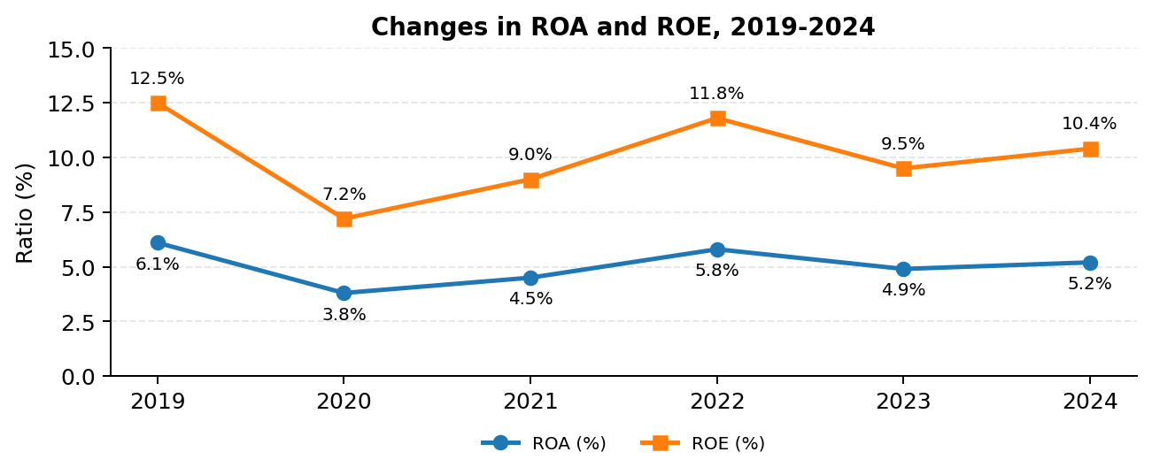
The profitability of listed logistics enterprises fluctuated substantially over 2019-2024. The average ROA of the dataset was 7.49%, but with a large standard deviation, a minimum value of -34.39% and a maximum value of 53.60%, indicating considerable differences among enterprises. The average ROE was 3.08% and varied sharply, reflecting the effects of capital structure, accumulated losses or changes in equity at some firms.
Over time, 2020 was a period of strong decline, when ROA fell from 6.1% to 3.8% and ROE from 12.5% to 7.2%. During 2021-2022, profitability recovered, with ROA rising to 5.8% and ROE to 11.8%. However, in 2023 the indicators declined again before a modest recovery in 2024. By the end of the period, both ROA and ROE remained below their 2019 levels.
From a segment perspective, the seaport and ICD group had ROA of 8.6% and ROE of 13.4%, higher than the other segments. The express delivery and 3PL group had ROA of 4.9%, the lowest among segments, despite its relatively high insider ownership. This indicates that profitability depends heavily on asset utilization, revenue model, competitive intensity and governance quality, rather than ownership ratio alone.
2.3. Testing the impact of ownership structure on the profitability of listed logistics enterprises in Vietnam
2.3.1. Descriptive statistics of ownership structure of logistics enterprises
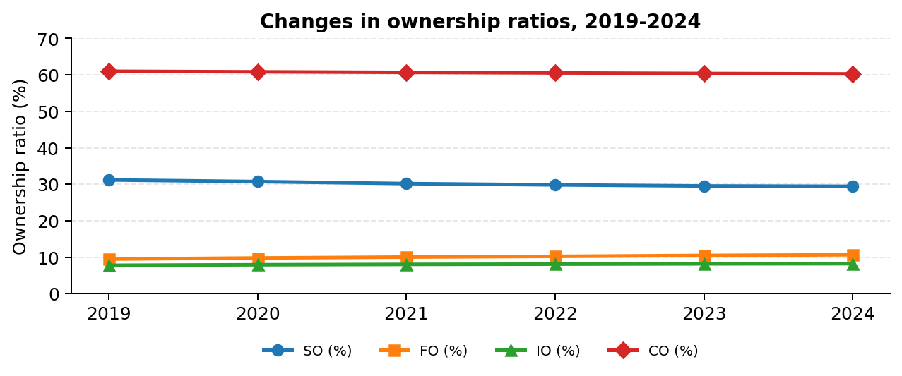
Descriptive statistics show that listed logistics enterprises have highly concentrated ownership, while considerable differences exist across segments in SO, FO, IO and CO. This provides the basis for further testing the impact of each ownership component on profitability.
2.3.2. Descriptive statistics of profitability of logistics enterprises
ROA and ROE vary significantly across enterprises and years, reflecting differences in size, capital structure, asset-use efficiency and business segment. Therefore, the use of panel data is appropriate for evaluating the relationship between ownership structure and profitability.
2.3.3. Testing results
The dissertation tests the impact of ownership structure on profitability using panel data with two dependent-variable models: ROA and ROE. The ownership variables are SO, FO, IO and CO, while the control variables are SIZE, LEV and GROWTH. The testing procedure is designed to ensure that the selected model is appropriate for the data characteristics.
The multicollinearity test shows that the average VIF is 1.23, indicating that multicollinearity is not a serious problem. The F-test comparing Pooled OLS and FEM yields a p-value of 0.0000, indicating that FEM is more appropriate than Pooled OLS. The Breusch-Pagan LM test also yields a p-value of 0.0000, showing that REM is more appropriate than Pooled OLS. The Hausman test has a p-value of 0.5580, so the null hypothesis that REM is appropriate relative to FEM is not rejected.
However, diagnostic tests indicate heteroskedasticity and autocorrelation in both the ROA and ROE models. For the ROA model, the Modified Wald test has Chi2 = 436.27 and the Wooldridge test has F = 18.64. For the ROE model, the Modified Wald test has Chi2 = 512.76 and the Wooldridge test has F = 22.35. Therefore, the dissertation uses FGLS to correct for heteroskedasticity and autocorrelation, while also comparing the results with Pooled OLS, FEM and REM to ensure consistency.
2.3.4. Analysis of the impact of ownership structure on profitability
The FGLS results with ROA as the dependent variable show that state ownership has a coefficient of 0.085 and is statistically significant at the 5% level. This indicates that, in the research sample, state ownership is positively associated with ROA. The result is consistent with the reality that some logistics enterprises connected with strategic infrastructure such as seaports, ICDs and air logistics may benefit from asset advantages, market position, policy relationships and access to long-term resources.
Foreign ownership has a coefficient of 0.055 and is statistically significant at the 5% level, indicating that FO is positively associated with ROA. This reflects the role of foreign shareholders in supporting capital, technology, managerial experience, transparency standards and market networks. Nevertheless, the average foreign ownership ratio remains relatively low, implying substantial room for foreign shareholders to play a stronger role.
Concentrated ownership has a coefficient of 0.035 and is statistically significant, suggesting that the presence of large shareholders may strengthen monitoring, financial discipline and control over investment decisions. By contrast, insider ownership has a coefficient of -0.004 and is not statistically significant. This implies that increasing insider ownership mechanically is not sufficient to improve ROA. Among the control variables, LEV is negatively associated with ROA, while GROWTH and SIZE are positively associated with ROA.
With ROE as the dependent variable, the FGLS results show that state ownership has a coefficient of 0.055 and is statistically significant at the 5% level. This is consistent with the ROA model in terms of the direction of association, but the coefficient is lower, suggesting that the role of state ownership in equity profitability should be considered together with capital structure and the quality of state capital governance.
Foreign ownership has a coefficient of 0.055 and is statistically significant, confirming a positive relationship between FO and the ability to generate returns for shareholders. Concentrated ownership continues to have a coefficient of 0.035 and is statistically significant, reflecting the monitoring role of large shareholders. Meanwhile, insider ownership has a coefficient of 0.004 but is not statistically significant, similar to the ROA model. This provides an important basis for not recommending a mechanical increase in insider ownership; instead, insider ownership should be conditional and linked to KPIs and governance responsibility.
The control variables show that LEV is positively associated with ROE, reflecting the amplifying effect of financial leverage on shareholder returns. GROWTH has a positive effect, whereas SIZE has a negative coefficient for ROE, indicating that larger scale does not always translate into higher shareholder profitability if governance and capital-use efficiency are not commensurate. Overall, the ROA and ROE results both indicate that SO, FO and CO have positive relationships with profitability, while IO has not demonstrated a clear role.
2.4. Assessment of the current impact of ownership structure on profitability
2.4.1. Achievements
First, the dissertation identifies a positive and statistically significant relationship between state ownership and both ROA and ROE in the sample of listed logistics enterprises. This suggests that, in a capital-intensive and infrastructure-related industry, state ownership may still provide certain advantages when effectively governed, especially in strategic segments.
Second, foreign ownership is positively associated with both ROA and ROE. This confirms that foreign shareholders contribute not only capital but also technology, governance, markets and monitoring capability. However, because the average FO ratio remains low, the key requirement is to attract strategic foreign investors with long-term commitments rather than merely increasing ownership for financial purposes.
Third, concentrated ownership has a positive effect, showing that large shareholders play a role in monitoring enterprises. However, given the high average level of CO, enterprises must simultaneously control the risk of control abuse and conflicts of interest with minority shareholders. Fourth, insider ownership is not statistically significant, implying that current insider ownership mechanisms are not strong enough to improve profitability. This is the basis for designing conditional insider ownership rather than increasing it mechanically.
2.4.2. Limitations and causes
Although listed logistics enterprises recovered after 2020, their profitability remained unstable and did not return to the 2019 level. Net revenue, profit after tax, ROA, ROE and ROIC in 2024 were still lower than at the beginning of the period. This indicates limitations in asset utilization, cost control, capital use and resilience to market fluctuations.
Regarding ownership structure, state ownership has a positive effect in the model but has not been uniformly effective across segments. Foreign ownership is significant and positive, but the average ratio remains low and strategic participation remains limited. Concentrated ownership has a monitoring role but may create conflicts of interest if transparency and minority shareholder protection are inadequate. Insider ownership is not statistically significant, indicating that the mechanism for aligning managerial and shareholder interests is not yet clear.
Objective causes arise from the characteristics of logistics, including high asset intensity, high fixed costs, volatility in freight rates, international trade, fuel costs and infrastructure quality. Subjective causes include unclear ownership strategies, state capital governance not sufficiently linked to profitability KPIs, limited absorptive capacity for resources from foreign shareholders, incomplete mechanisms for controlling large shareholders and insider ownership policies not yet connected to operating results and firm value.
Conclusion of Chapter 2
Chapter 2 analyzes the current status of ownership structure, profitability and empirical testing results. The evidence shows that SO, FO and CO have positive relationships with ROA and ROE, whereas IO is not statistically significant. These findings provide the direct basis for the solution system developed in Chapter 3.

CHAPTER 3: SOLUTIONS TO IMPROVE OWNERSHIP STRUCTURE TO ENHANCE THE PROFITABILITY OF LISTED LOGISTICS ENTERPRISES IN VIETNAM
3.1. Development orientation of listed logistics enterprises in Vietnam
3.1.1. Development orientation of Vietnam’s logistics industry
Vietnam’s logistics industry is oriented toward infrastructure modernization, service quality improvement, logistics cost reduction, expanded supply-chain connectivity, accelerated digital transformation and green logistics development.
3.1.2. Development orientation of logistics enterprises in Vietnam
The development orientation of listed logistics enterprises in Vietnam in the coming period is associated with improving competitiveness, expanding value-added services, modernizing infrastructure, promoting digital transformation, developing green logistics and strengthening international supply-chain connectivity. In this context, ownership structure should be improved in a way that supports access to long-term capital, technology, modern governance and market networks.
3.2. Viewpoints on improving ownership structure to enhance profitability
The first viewpoint is that improving ownership structure must be linked to the objective of sustainable profitability enhancement. ROA should be regarded as a fundamental indicator for a capital-intensive industry, while ROE should be used as a supplementary indicator and assessed together with financial leverage. ROE should not be maximized by excessive debt expansion.
The second viewpoint is that there is no optimal ownership structure applicable to all enterprises. Ownership structure must be suitable for each business segment, the strategic nature of assets, firm size and governance capability. The third viewpoint is that improving ownership structure must simultaneously promote the roles of state shareholders, foreign shareholders, large shareholders and insiders, while controlling conflicts of interest, enhancing transparency and protecting minority shareholders.
3.3. Solutions to improve ownership structure to enhance profitability
3.3.1. Attract selective foreign ownership associated with technology transfer and governance improvement
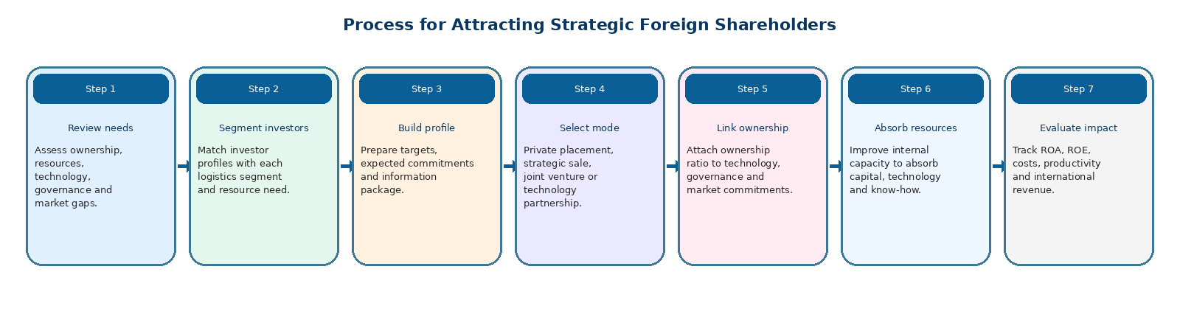
First, enterprises should attract foreign ownership selectively, associated with technology transfer, governance improvement and market expansion. Increasing FO should not be understood as a mechanical objective; it should be directed toward strategic shareholders capable of supporting warehousing technology, supply-chain management, digital systems, international customer networks and corporate governance standards. Enterprises need to review resource needs, develop strategic investor profiles and select appropriate forms of participation such as private placement, strategic share sale, joint venture or technology cooperation.
The target for 2026-2027 is to increase the average FO ratio to about 13%-15%, and by 2028-2030 to about 18%-20%. In warehousing, 3PL, express delivery and value-added services, the ratio may reach 20%-30% if legal conditions and absorptive capacity permit. The expected effects include a 5%-10% reduction in operating costs and improvements in ROA and ROE at enterprises with substantive strategic shareholders.
3.3.2. Restructure state ownership toward efficiency, transparency and a clear roadmap
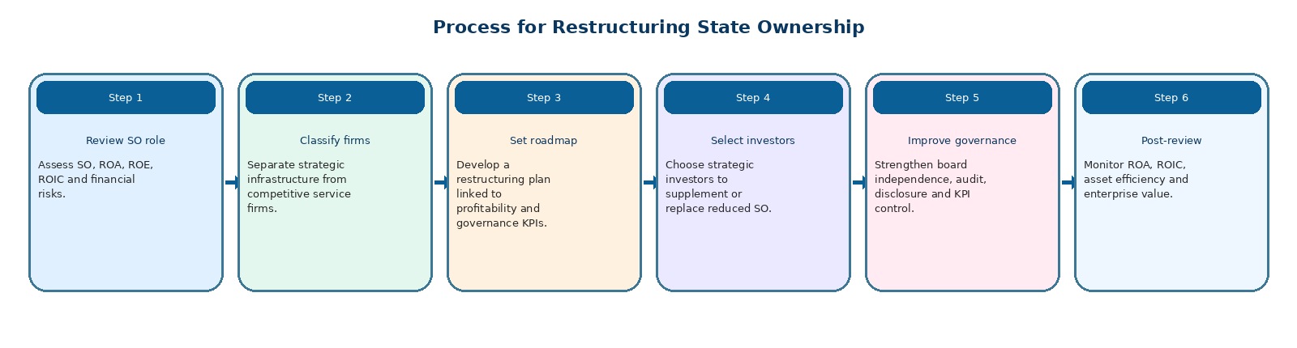
Second, state ownership should be restructured toward efficiency, transparency and a clear roadmap. For enterprises that play a strategic infrastructure role, the State may maintain an appropriate ownership ratio, but this must be tied to profitability KPIs and state capital governance. For enterprises outside strategic segments, divestment should be promoted, reducing SO to 25%-35% or lower depending on conditions, while selecting replacement strategic investors to improve governance and asset-use efficiency.
3.3.3. Build conditional insider ownership and avoid mechanical increases
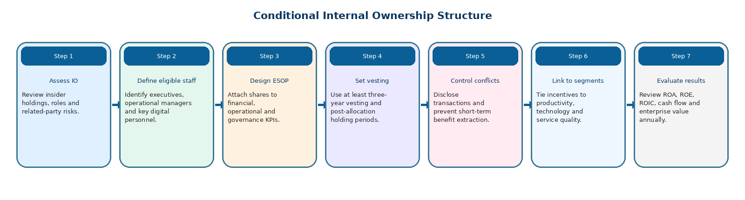
Third, insider ownership should be designed conditionally and should not be increased mechanically. Since IO is not statistically significant in either the ROA or ROE model, the dissertation does not recommend increasing IO as an independent solution. Instead, enterprises should design ESOPs or conditional share-award programs linked to financial, operational, governance and digital-transformation KPIs. Each ESOP issuance should account for about 1%-3% of outstanding shares, include a minimum holding period of three years and be distributed only when KPI thresholds approved by the General Meeting of Shareholders are achieved.
KPI indicators may include ROA, ROE, ROIC, cash flow, asset productivity, operating costs, service quality, digitalization and disclosure compliance. This approach transforms insider ownership into a long-term incentive mechanism rather than a tool for short-term benefit distribution.
3.3.4. Control concentrated ownership risks and protect minority shareholders
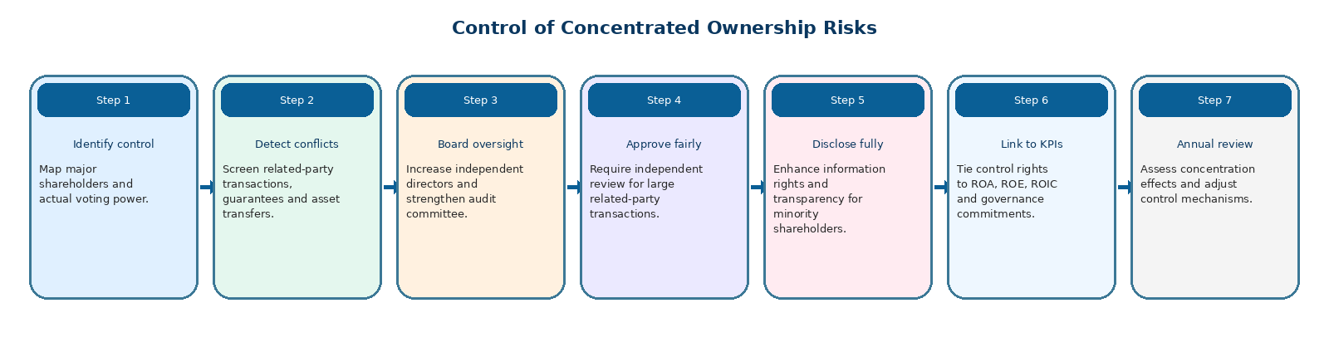
Fourth, enterprises should control concentrated ownership risks and protect minority shareholders. Since CO is positively associated with ROA and ROE but the level of concentration is high, enterprises need to maintain the monitoring role of large shareholders while establishing safeguards against conflicts of interest. Measures include increasing the proportion of independent board members, strengthening the audit committee, fully disclosing related-party transactions, establishing independent approval mechanisms for large transactions and expanding minority shareholders’ access to information.
3.3.5. Internal governance solutions and ownership optimization by logistics segment
In addition to ownership-specific solutions, enterprises should implement internal governance solutions and optimize ownership structure according to logistics segment. For seaport and ICD enterprises, ownership structure should ensure long-term capital, infrastructure investment capability and effective asset governance; if state capital is present, it should be linked to ROA, ROIC and port utilization indicators.
For maritime transport and ship agency enterprises, the focus should be on controlling leverage, reducing volatility in financial costs and improving market risk management. For warehousing and forwarding enterprises, priority should be given to attracting foreign or strategic shareholders with technology, customer networks and supply-chain management experience. For express delivery and next-generation 3PL enterprises, insider ownership should be designed only as a conditional incentive mechanism linked to operating productivity, technology platforms and service quality.
For air logistics enterprises, ownership structure should balance strategic requirements, long-term capital, safety standards and international connectivity. Overall, enterprises should enhance information transparency, standardize corporate governance, control related-party transactions, optimize capital structure, improve asset utilization and establish mechanisms for periodically assessing the impact of each shareholder group on ROA, ROE and firm value.
3.4. Conditions for implementing solutions and recommendations
For the proposed solutions to be effective, coordination is required among enterprises, shareholders, state management agencies and the capital market. On the enterprise side, the most important conditions are improving disclosure quality, standardizing governance reports, ensuring transparency in related-party transactions and establishing mechanisms for evaluating the effectiveness of capital held by each shareholder group. Enterprises should develop medium- and long-term shareholder strategies that clarify the roles of state shareholders, foreign shareholders, large shareholders and insiders in relation to profitability objectives.
On the side of state management agencies, the legal framework on state divestment, foreign ownership limits, minority shareholder protection and disclosure by listed enterprises should continue to be improved. In logistics, policies should distinguish between strategic infrastructure segments and competitive service segments in order to determine appropriate ownership orientations. Non-sensitive segments may be more open to foreign strategic investors, while important infrastructure segments need clear criteria for maintaining state capital and effective monitoring mechanisms.
On the capital-market side, it is necessary to develop long-term institutional investors, improve the quality of logistics enterprise analysis, strengthen market discipline and encourage the adoption of good governance practices. These conditions help ensure that adjustments in ownership structure are not merely changes in shareholding ratios, but are transformed into genuine improvements in ROA, ROE and firm value.
Conclusion of Chapter 3
Chapter 3 proposes solutions to improve ownership structure selectively, based on empirical findings, segment characteristics and the objective of sustainable ROA and ROE enhancement. The solutions emphasize the role of strategic shareholders, state capital restructuring, conditional insider ownership, minority shareholder protection and internal governance optimization.

CONCLUSION

The dissertation "The impact of ownership structure on the profitability of listed logistics enterprises in Vietnam" systematizes the theoretical foundations of ownership structure, profitability and the mechanisms through which ownership structure affects profitability. It also develops a research model appropriate to the characteristics of the logistics industry and the context of listed enterprises in Vietnam.
Based on data from 58 listed logistics enterprises during 2019-2024, the dissertation shows that profitability fluctuated significantly and had not fully recovered to the 2019 level by the end of the period. The empirical results indicate that state ownership, foreign ownership and concentrated ownership are positively and statistically significantly associated with ROA and ROE, whereas insider ownership is not statistically significant. The control variables also show that size, growth and financial leverage should be taken into account when assessing profitability.
The findings should be interpreted as evidence of statistical associations rather than definitive causal effects, because ownership structure and profitability may influence each other. Nevertheless, the results provide a consistent basis for identifying the ownership components that are associated with better profitability and for designing feasible governance-oriented solutions.
On the basis of the findings, the dissertation proposes a system of solutions including: attracting selective foreign ownership; restructuring state ownership toward efficiency and transparency; building conditional insider ownership; controlling concentrated ownership risks and protecting minority shareholders; and optimizing ownership structure according to logistics segments. These solutions aim to improve sustainable profitability, corporate governance and competitiveness of listed logistics enterprises in Vietnam.
The dissertation contributes empirical evidence to ownership-structure theory in an emerging market and in a capital-intensive service infrastructure industry. It provides a scientific basis for enterprises seeking to optimize shareholder structure and for policymakers improving the institutional environment for logistics development. The study may serve as a reference for managers, investors, policymakers and researchers interested in corporate finance, governance and logistics in Vietnam.
Nevertheless, the research still has certain limitations. The observation period covers 2019-2024 and the sample is limited to listed enterprises, so future studies may expand the dataset to unlisted logistics enterprises and lengthen the time horizon. Subsequent research may also incorporate intermediate mechanisms such as labor productivity, digital transformation, green logistics practices and ESG factors in order to evaluate more comprehensively how ownership structure is transformed into sustainable profitability and enterprise value.

LIST OF PUBLICATIONS RELATED TO THE DISSERTATION TOPIC
- Dao Thu Ha, Ha Van Sang, Nguyen The Anh (2023), Logistics and supply chain risk management in Vietnam, Review of Finance, 6, 51–54.
- Nguyen The Anh, Dao Thu Ha (2024), Impact of ownership structure on the profitability of Vietnamese logistics enterprises, Journal of Economics and Forecasting ,12, 47–50.
- Anh The Nguyen, Ha Thu Dao (2024), Factors influencing cash holdings of listed logistics companies in the Vietnamese stock market, Proceedings of the 5th International Conference on Research in Management and Technovation (ICRMAT), pp. 635–646.
- Dao Thu Ha (2025), Improving the business performance of logistics enterprises on the Vietnamese stock market, Journal of Economics and Forecasting,2, 218–221.
- Dao Thu Ha, Nguyen The Anh (2026), Impact of ownership structure on profitability: Evidence from listed logistics firms in Vietnam, Journal of Economics and Finance, Issue 1/9, 39–42.

